首届窑房国际驻场空间“野生”艺术节海选申请表
Application Form for the Preliminary Selection of the First KilnRoom JDZ “Call Of The Wild”Art Competition
姓名  Name |  | 性别  Gender |  | 艺术家照片  Artist Portrait
出生年月  Birth |  | 国籍  Nationality
邮箱  E-mail |  | 职业  Occupation
微信号/手机号  Wechat Account/  Phone number |  | 小红书/INS  Red book/Instagram
网址
Website
艺术家简介 (200-300字左右)：
请提供一份关于您个人背景及艺术历程的简要介绍：
Artist Bio:
Please provide a brief bio about yourself, your background, and your artistic journey (200-300 words):

提供一些你过往艺术作品的照片：
Provide some photos of your past artwork:
过往作品 1 主题（名称）:
Previous work 1:
尺寸： 材料: 工艺或作品类型：
Size： Material: Process or type of work:
照片缩略图（Photo thumbnail）：

过往作品 2 主题（名称）:
Previous work 2:
尺寸： 材料: 工艺或作品类型：
Size： Material: Process or type of work:
照片缩略图（Photo thumbnail）：

过往作品 3 主题（名称）:
Previous work 3:
尺寸： 材料: 工艺或作品类型：
Size： Material: Process or type of work:
照片缩略图（Photo thumbnail）：

过往作品 4 主题（名称）:
Previous work 4:
尺寸： 材料: 工艺或作品类型：
Size： Material: Process or type of work:
照片缩略图（Photo thumbnail）：

过往作品 5 主题（名称）:
Previous work 5:
尺寸： 材料: 工艺或作品类型：
Size： Material: Process or type of work:
照片缩略图（Photo thumbnail）：

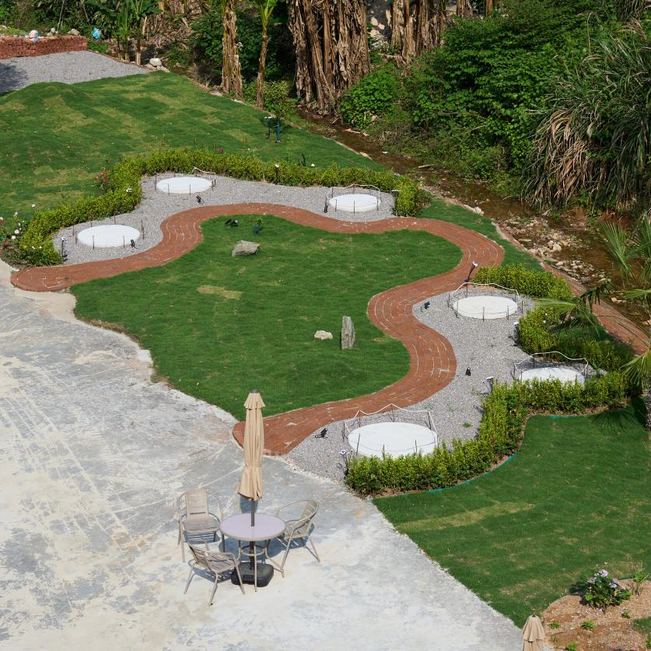

每位艺术家在我们雕塑花园中都配有一个宽度在100至130厘米之间的混凝土基座，用以展示他们的作品。装置或表演艺术作品也可利用混凝土平台或草坪进行艺术呈现。
艺术品将于8月1日起在现场或景德镇开始制作，并于8月16日进行展示和评审。
Each artist is provided a concrete plinth in our sculpture garden with a width ranging from 100-130 cm to display their works. Installation or performance artworks are also able to use the concrete pad or lawn for their art piece.
Artworks are made on site or in Jingdezhen beginning August 1st and will be displayed and judged August 16th.

项目提案：
请描述您提议的户外艺术作品。需包含概念构思、使用材料、尺寸规格等详细信息，并说明如何在两周时间内完成该作品。附上作品草图或效果图。（字数上限500字）
Project Proposal:
Describe your proposed outdoor art piece. Include details about the concept, materials, dimensions, and how you plan to complete the piece within the two-week time frame. Feel free to add any sketches or renderings of your work concept. (500 words max):

PS :
1.请详细的提交作品资料，并附上清晰的作品照片,请保证照片是 JPEG 格式的 。
Please submit the work information in detail with attached the work photos.Ensure that the photo is in JPEG format.

- 主办方将选出六位艺术家于8月1日-8月16日艺术驻场于窑房国际驻场空间。驻场期间将有机会接受来自海内外的资深“景漂”艺术家导师指导，最后在8月16日的艺术节将以观众与现场评委投票的方式，选出一位艺术家在窑房国际驻场空间免费驻场一年。
The organizers will select six artists for an art residency at the KilnRoom International Residency Space from August 1st to August 16th. During the residency, participants will have the opportunity to receive guidance from experienced "Jingpiao" local artist mentors from both domestic and international backgrounds. On August 16th, the art festival will conclude with an audience and on-site voting to select one artist for a free one-year residency at the KilnRoom International Residency Space.
3.请将填写完整的申请表发送至官方邮箱：kilnroomjdz@gmail.com，邮件主题注明"野生艺术节申请表"。如有任何疑问或建议，请发送邮件至官方邮箱kilnroomjdz@gmail.com，或通过Instagram @kilnroom.jdz/小红书@Kilnroomjdz/微信Kilnroomjdz私信联系我们。
Submit your finished application to kilnroomjdz@gmail.com with subject line reading “Call of the Wild Application”. For any questions or concerns please write to kilnroomjdz@gmail.com or direct message us on instagram @kilnroom.jdz / Red Book @Kilnroomjdz /Wechat Kilnroomjdz

